Educational Package



Technical Documentation: ER-4iA Robot with R-30*i*B Mate Plus Controller

**V5.3 ( S/W Version 9.3 )**

1

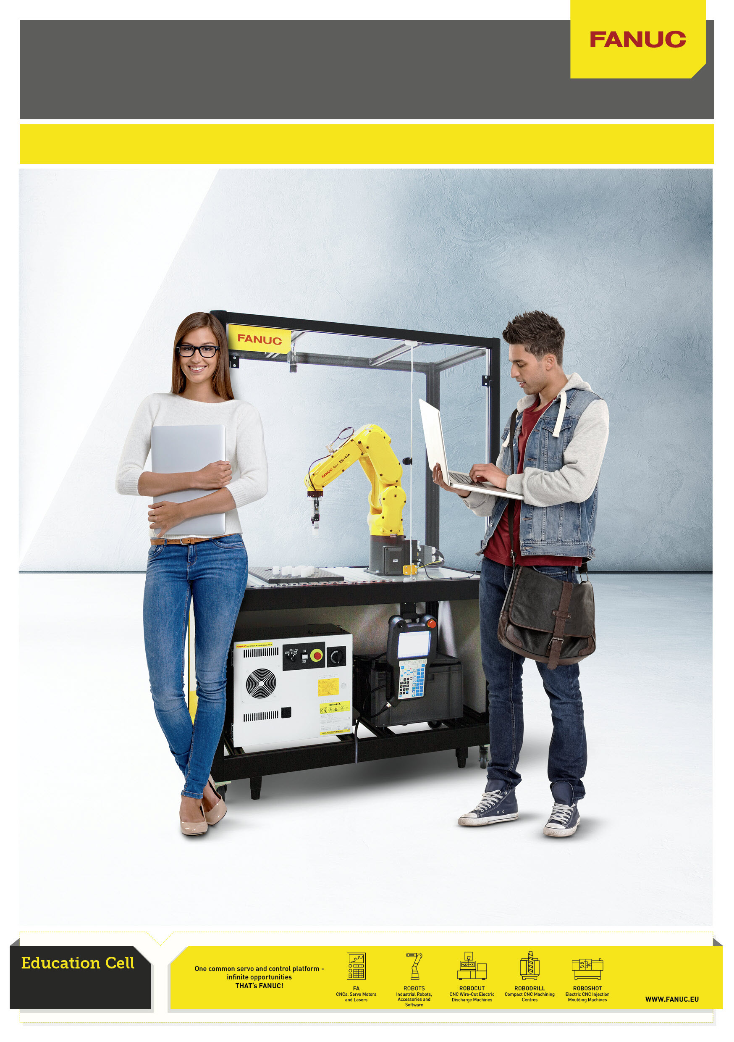

**1**

**Contents**

1

Installation / Quick Start Guide ............................................................................................................... 5

2

Safety ......................................................................................................................................................... 6

2.1

General Instructions ................................................................................................................... 6

2.2

AUTO/T1/T2 Switch...................................................................................................................... 7

2.3

DCS Password ............................................................................................................................. 7

3

Selecting and running Example program ............................................................................................... 8

3.1

Start Up Screen ........................................................................................................................... 8

3.2

Example Program “AAA_DEMO” ................................................................................................ 9

3.3

AAA_DEMO Program Sequence with / without

RVision ......................................................... 13

*i*

3.4

Operation Menu Display ............................................................................................................ 14

3.5

4D Graphics (Option) ................................................................................................................. 15

4

Demonstration Program Setup / Teaching ........................................................................................... 16

4.1

Gripper Setup............................................................................................................................. 16

4.2

UFrame 2 Setup ......................................................................................................................... 17

4.3

Orient Origin Point ..................................................................................................................... 19

4.4

X-Direction Point ....................................................................................................................... 20

4.5

Y-Direction Point ....................................................................................................................... 21

5

Robot Setup ............................................................................................................................................ 22

5.1

UTOOL / TCP Setup ................................................................................................................... 22

5.2

Payload Setup ............................................................................................................................ 22

5.3

DCS Setup .................................................................................................................................. 23

5.3.1

DCS Tool Model. ........................................................................................................................ 23

5.3.2

DCS Safe Zone ........................................................................................................................... 24

5.4

I/O Setup .................................................................................................................................... 25

5.5

Macro Setup ............................................................................................................................... 26

5.6

TP Function Key Hint Screen .................................................................................................... 27

5.7

Home / Reference Position ....................................................................................................... 28

5.8

Power Up Program .................................................................................................................... 29

6

RVision Setup ( Option ) ......................................................................................................................... 30

*i*

6.1

Camera Adjustment .................................................................................................................. 30

6.2

Application Frame ..................................................................................................................... 32

6.3

Camera Calibration ................................................................................................................... 33

6.4

Example

RVision Application ................................................................................................... 35

*i*

6.5

RVision Tips .............................................................................................................................. 36

*i*

6.6

TP Program................................................................................................................................ 38

7

IoT / Industrie 4.0 / PC Connection ........................................................................................................ 39

7.1

Physical Ethernet connection ................................................................................................... 39

7.2

Robot Software Setup ............................................................................................................... 40

7.3

PC Setup .................................................................................................................................... 41

7.4

Robot Homepage ....................................................................................................................... 42

7.5

File Transfer .............................................................................................................................. 44

7.6

Roboguide Simulator / File Transfer ........................................................................................ 45

2



8

List of Registers ..................................................................................................................................... 48

8.1

Numeric registers ..................................................................................................................... 48

8.2

Position Registers ..................................................................................................................... 50

9

Program Details ..................................................................................................................................... 51

9.1

List of programs ........................................................................................................................ 51

9.2

Sample Program Listings ......................................................................................................... 54

10

User Interface Setup .............................................................................................................................. 56

10.1

Menu Utility Setup ..................................................................................................................... 56

10.2

HTML Screens ........................................................................................................................... 57

10.3

HTML Listing Extract ................................................................................................................. 58

11

Electrical Drawings ................................................................................................................................ 62

11.1

Power and Fence ....................................................................................................................... 62

11.2

Gripper ....................................................................................................................................... 63

12

Bill of Materials ...................................................................................................................................... 64

13

Technical & Transport Data ................................................................................................................... 65

14

Version .................................................................................................................................................... 66

**Disclaimer**

This documentation has been provided by FANUC Europe Corporation S.A. (“FANUC”) for

convenience and general information purposes only, with no intention of providing comprehensive,

complete, accurate or up to date information. Therefore, FANUC does not warrant or assume any

legal liability or responsibility whatsoever for the accuracy, completeness, or usefulness of any

information, application, apparatus, product, use, processes or services disclosed herein.

Should you be interested in obtaining specific information or advice on FANUC applications,

apparatus, products, use, processes or services, please contact FANUC at:

FANUC Europe Corporation

Société Anonyme

Zone Industrielle

L-6468 Echternach

Grand Duchy of Luxembourg

Tel.: +352-727777-1

3



**INTENDED USE OF EDUCATION CELL**

**The Education Cell is intended for Education and Training Purposes**

**It is designed for lightness and portability,**

**not for high speed robot motion or full acceleration.**

**If robot is programmed to move aggressively**

**then this may result in undesirable shaking of the frame,**

**even resulting in the activation of the door safety switch.**

Please avoid such unintended use.

4



**1**

**Installation / Quick Start Guide**

**Step 1**

Unpack the Cell,

**Step 5**

Turn on the Main

Power Switch and

follow the

instructions on the

wheel it into

program

position and

adjust the frame

feet

**Step 2**

Teach Pendant to

run the Demo

Download and

read the

**Step 4**

Remove the Auto-T1-

T2 switch key from

inside the controller

and insert into the

switch on the front of

the controller in the

Technical

Auto position

Documentation:

www.fanuc.eu/

educational-

**Step 3**

package

Remove the Teach

Pendant from the

accessory box and

connect the Teach

Pendant and Power

cables

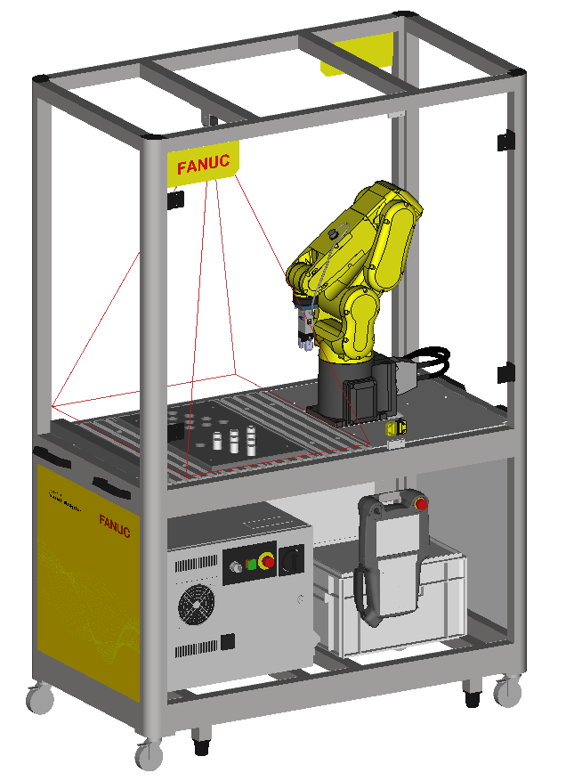

5



**2**

**Safety**

**2.1**

**General Instructions**

Students / new users should be supervised by competent persons who are responsible for their

safety.

Users’ bodies should not enter the cell while moving/programming the robot

**OK**

**NOK**

Working in Cell **without**

Programming

Programming with TP

**Teach Pendant/ Servo OFF**

Outside Cell

Inside Cell

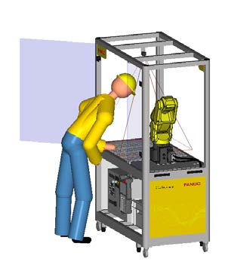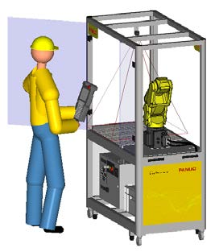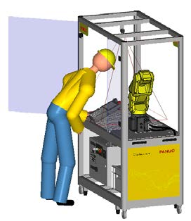

**When installing, connecting peripherals etc, Servo power must be cut by E-Stop on Teach Pendant**

**or Controller.**

Users should not crowd around one another, especially in front of the cell door

**OK**

**NOK**

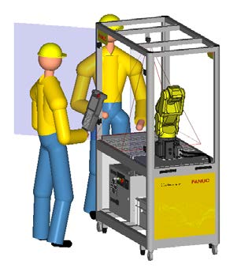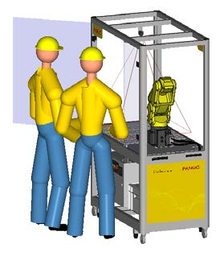

**For more information please refer to FANUC Safety Handbook B-80687EN/15**

6



**2.2**

**AUTO/T1/T2 Switch**

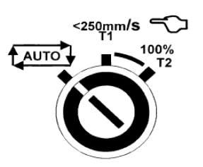

Users should do setup / programming etc in T1 mode ( <250mm/s ) whenever possible.

T2 Mode should be reserved for Test Run and used with caution.

Auto Mode can be used with the door closed after setup and programming are complete.

**Use of the Auto / T1 / T2 key should be restricted to authorised persons.**

**2.3**

**DCS Password**

Please note that the DCS password has been left at the default value of ‘1111’. It is the User’s

responsibility to decide if it is necessary to change this – for instance if unauthorised access to the

cell may result in DCS settings being unexpectedly changed or disabled. Correct DCS settings are

necessary for safe operation of the cell – especially in Auto or T2 Mode.

**If the DCS Password is changed please make sure to keep a note of the new password in a safe**

**place – if DCS password is lost it is necessary to contact your FANUC representative to recover.**

7



**3**

**Selecting and running Example program**

**3.1**

**Start Up Screen**

When the robot controller is turned on, it displays the following Start-Up Instructions:

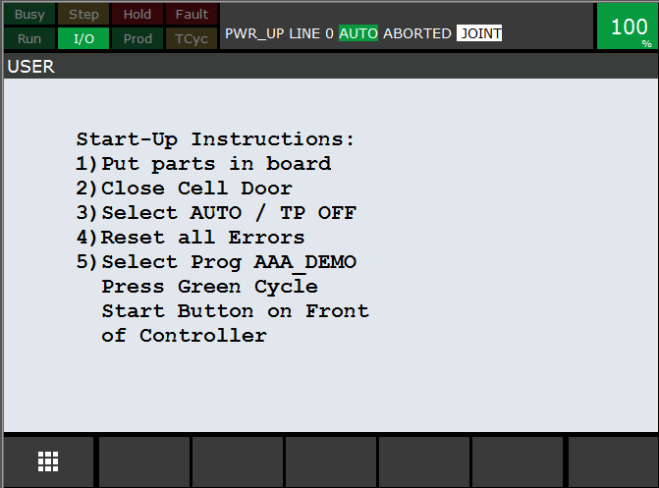

8



**3.2**

**Example Program “AAA_DEMO”**

The program “AAA_DEMO” has been provided as an example program.

It transfers the cylindrical parts supplied from one triangular ‘solitaire’ board to another.

To start the program follow these steps:

a.

Robot must be in ‘AUTO’ mode, all E-Stops released, and cell door (‘Fence’) closed

b.

Robot should not be in error condition. If robot shows error condition press the “RESET” key

on the Teach pendant to try to reset the errors.

c.

Select the program “AAA_DEMO” and Press the ‘Cycle Start’ button on the front of the

controller.

(Teach pendant enable switch must be OFF and Auto/T1/T2 switch must be in ‘Auto’ position)

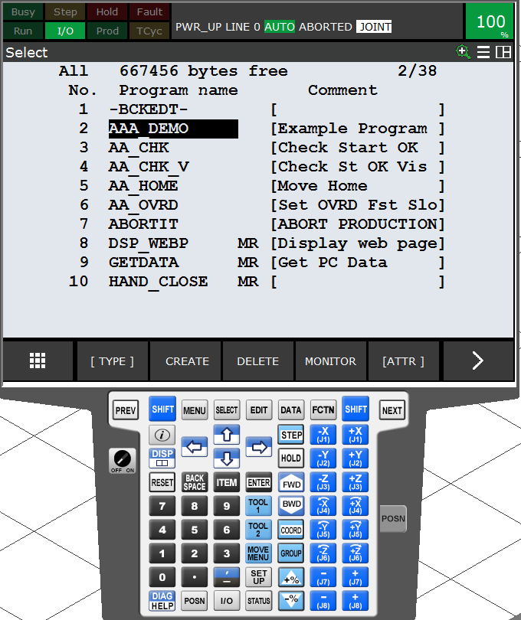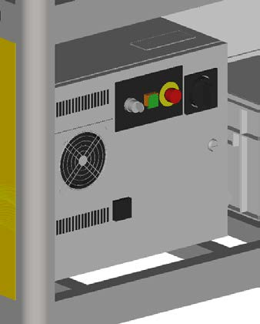

Please note – program “AAA_DEMO” must be selected before pressing ‘Cycle Start”

9



d.

The program AAA_DEMO expects to be started from the HOME position:

Robot at HOME

Robot not at HOME

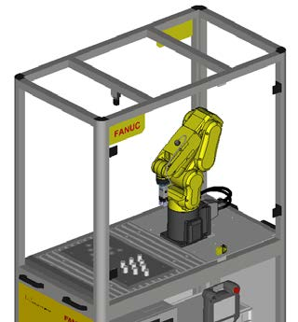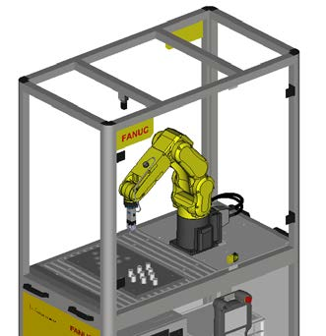

If the Robot is not at the HOME position, the

following screen will appear:

Choose the appropriate action and press

‘ENTER’

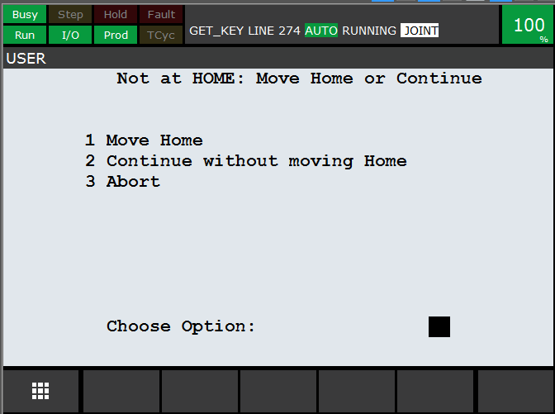

If Option 2 “ Continue “ is chosen, then a confirmation screen will be displayed:

Note that these two functions have been

implemented using the ‘Menu Utility’

function – see later section for details.

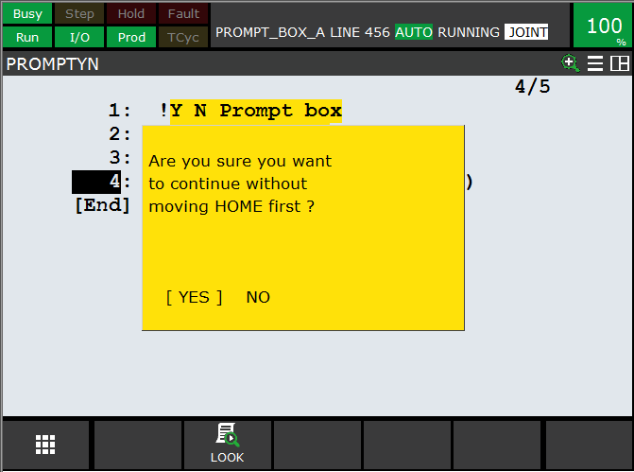

10



e.

Before the program starts, a screen will ask for confirmation that the parts are in the

correct starting position:

Make sure that the parts are in the

positions shown, then press “Continue”.

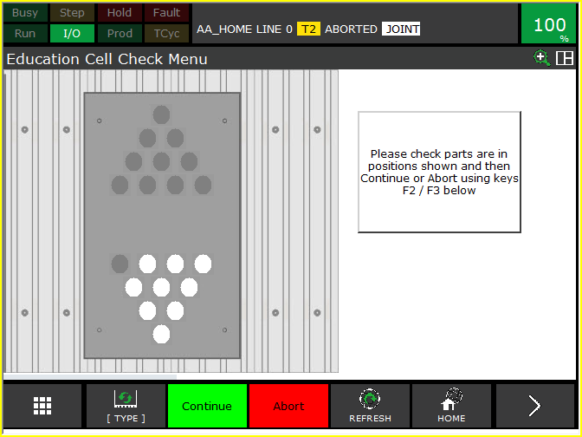

f.

When the program is running, a Status / Menu screen is shown:.

The red/white circles show the current

position of the pieces

There are two function Key Selections: End

Cycle / Continue and Fast/Slow.

If ‘End Cycle’ is pressed, this changes

Register R[1] from 1 to 0, and the Cycle

Stop status changes from Inactive to Active:

This will mean that the program will stop at

the end of the next complete cycle and the

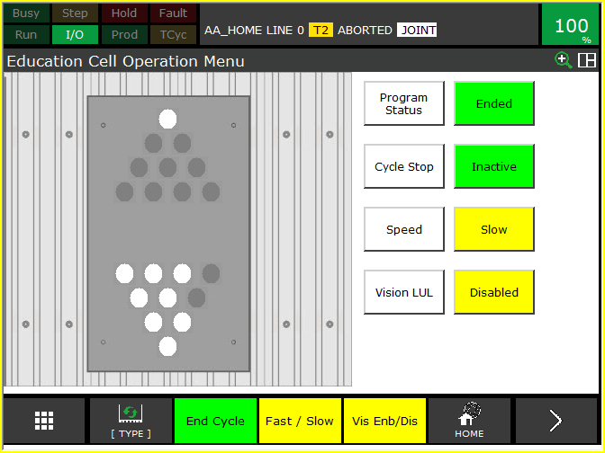

Program Status will then become ‘Ended’

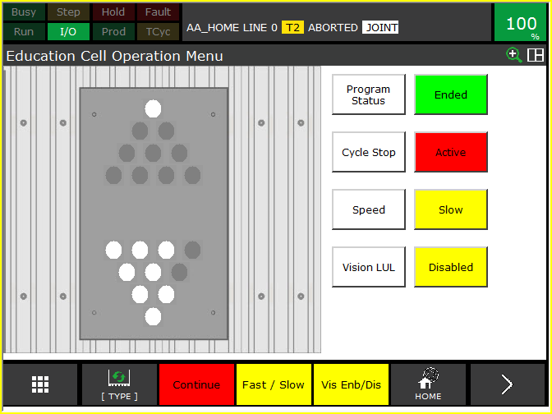

11



g.

Likewise, the Fast/Slow Function key changes the Override:

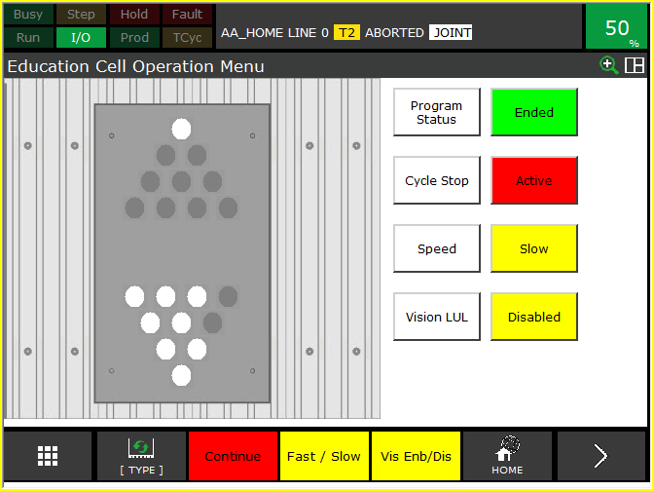

Note: the Fast / Slow Override speeds are

set according to the values in R[4] and R[5]

– see later section for details

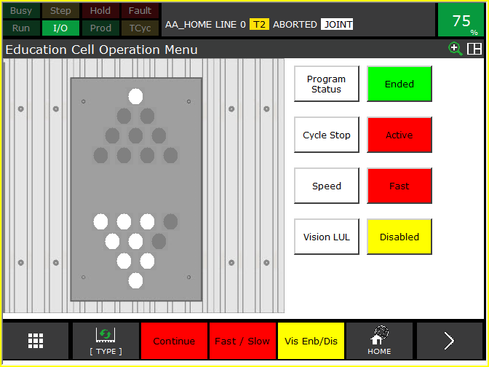

And the F4 function Key enables / disables

the Vision Load / Unload section of the

program – see next section for details.

Note:

RVision must be installed and set up

*i*

for this function to be used.

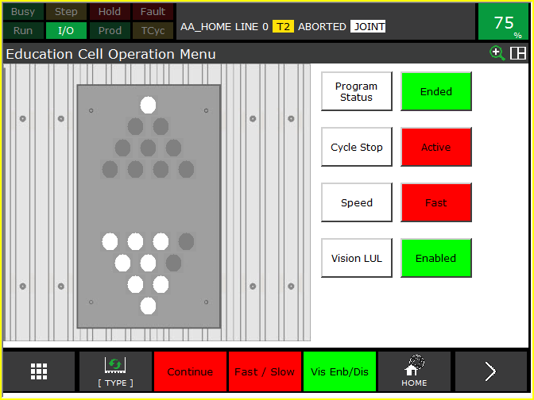

12



**3.3**

**AAA_DEMO Program Sequence with / without**

**RVision**

***i***

There are 3 basic positions for the parts in/on the Solitaire board:

In the Left Hand side of the board:

This is the start and end position of the example

program

If Vision L/UL is Disabled then

sequence is:

Move Parts from Left Hand side to

•

Right Hand side

Move Parts from Right Hand side

•

to Left Hand side

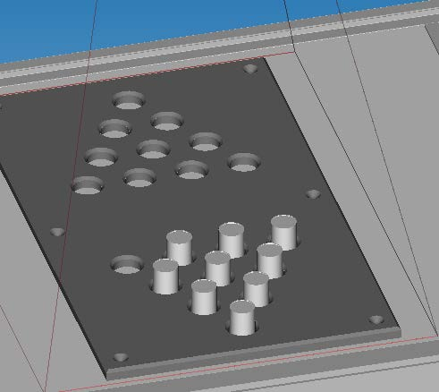

In the Right Hand side of the board:

Repeat

•

If Vision L/UL is Enabled then

sequence is:

Move Parts from Left Hand side to

•

Right Hand side

Move Parts into middle of board

•

Move Parts from middle of board

•

to Left Hand side using

RVision.

*i*

Repeat

•

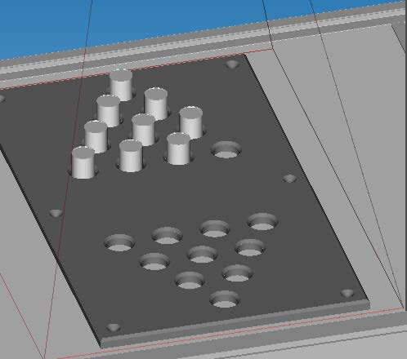

On the middle of the board:

This position is only used if

RVision is enabled for the

*i*

example program using “F4” function key

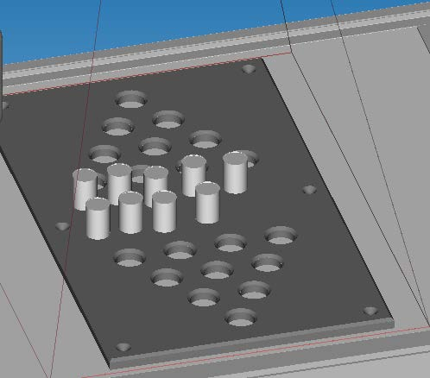

13



**3.4**

**Operation Menu Display**

The Operation Menu can be displayed at any time by pressing the MENU key and then

selecting the “Operate” shortcut that pops up:

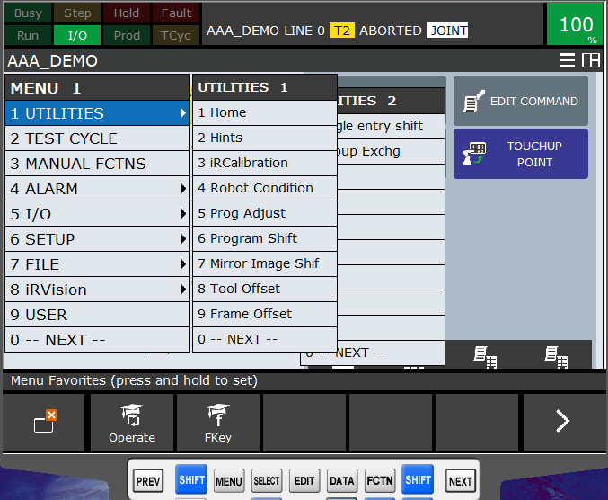

14



**3.5**

**4D Graphics (Option)**

The “4D Graphics” function is available as an option, with a model of the cell loaded into the robot

controller.

This model can be displayed by pressing the MENU button and selecting “4D Graphics”:

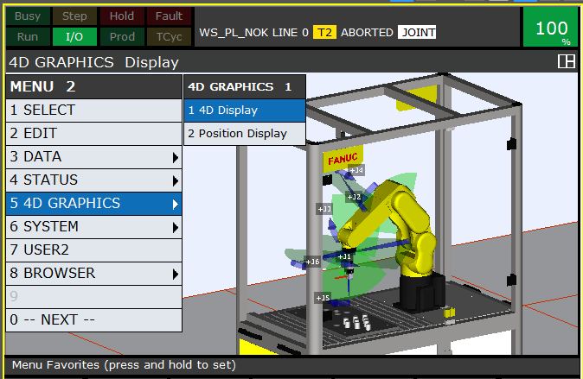

The 4D graphics function has many features, for example as shown below the display of the Jog

Coordinates – in this case the WORLD Jog Coordinate System:

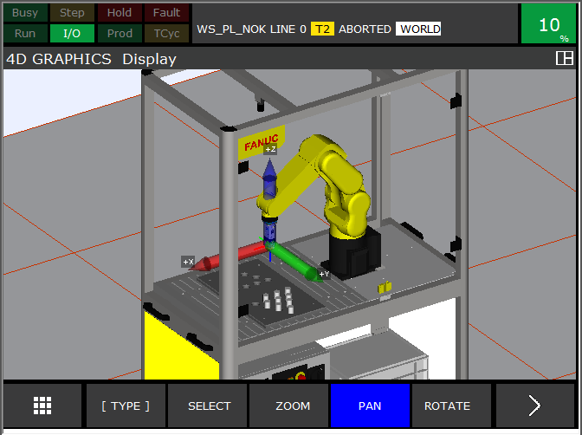

15



**4**

**Demonstration Program Setup / Teaching**

The positions of the holes in the tray are calculated, not taught – so there should be no need to

touchup / reteach the individual hole positions. However, it may be necessary to touchup / reteach

the User Frame (UFrame) which defines the position of the tray relative to the robot.

**4.1**

**Gripper Setup**

To teach the positions it is necessary to use a part held in the gripper.

Gripper Force should be set at 50% using the small rotary switch on the gripper.

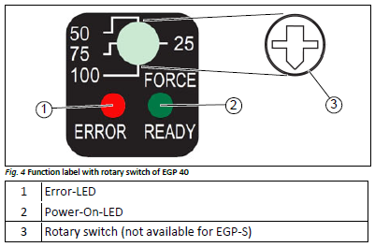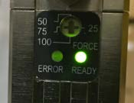

16



**4.2**

**UFrame 2 Setup**

The User Frame touchup is done using the Menu>Setup>Frames function:

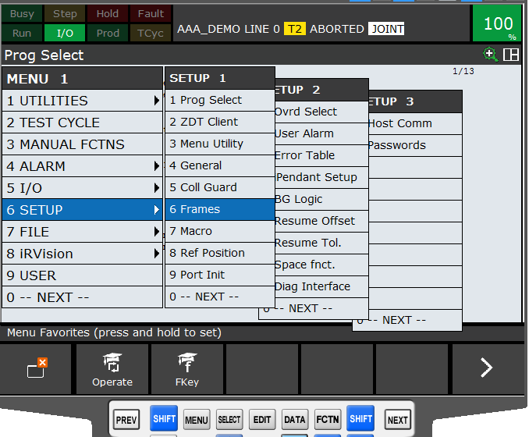

This requires 3 Points to be touched-up / re-taught:

Note that the MOVE_TO function key provides a

method to easily check the current taught

positions

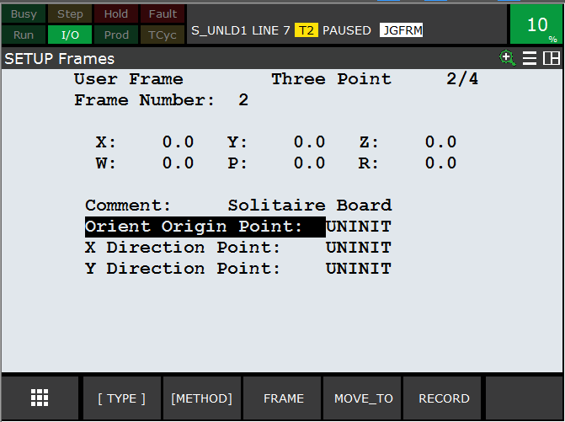

17



First, insert a piece into the gripper:

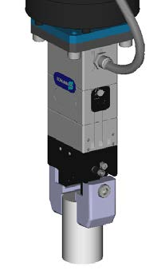

Make sure gripper is vertical, and jog the robot so that the piece is central in the Left-most hole on

the tray shown below:

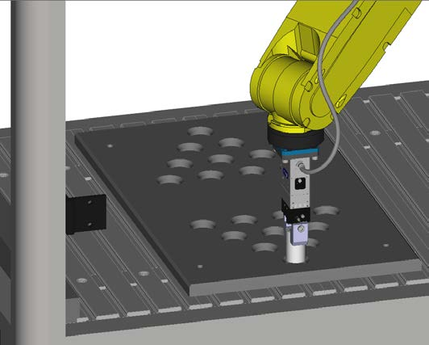

18



It is difficult to know when the piece is touching the table at the bottom of the hole – so this

position is not used for the reference point.

Instead, jog the robot upwards using WORLD+Z until the bottom of the piece is just above the top of

the tray. Use a thin piece of card to help judge this correctly:

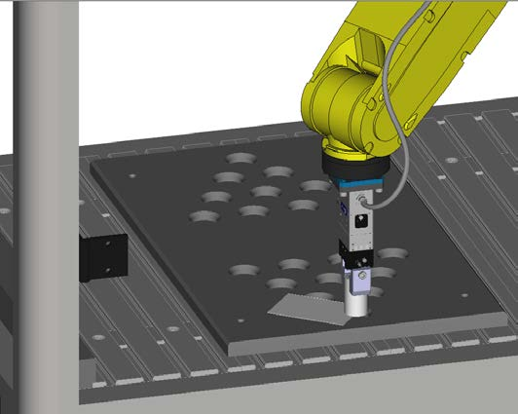

**4.3**

**Orient Origin Point**

Then RECORD this position as Orient Origin Point – see below:

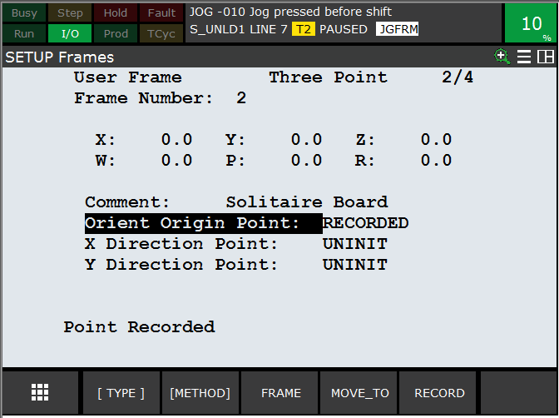

19



**4.4**

**X-Direction Point**

Now do the same thing for the Right-most hole in the tray:

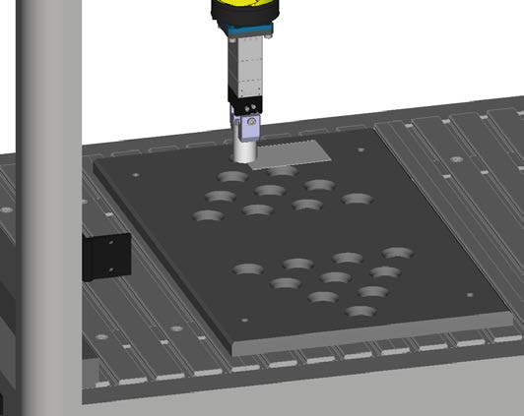

And RECORD this position as X-Direction Point – see below:

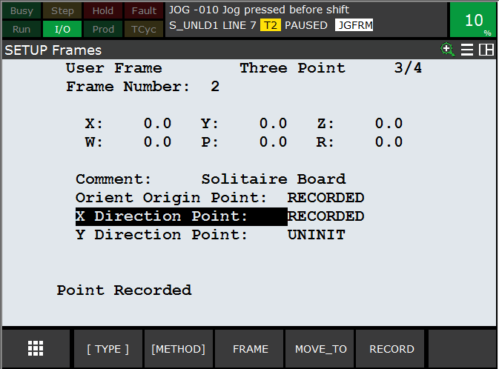

20



**4.5**

**Y-Direction Point**

And finally any position on the top surface of the front of the tray:

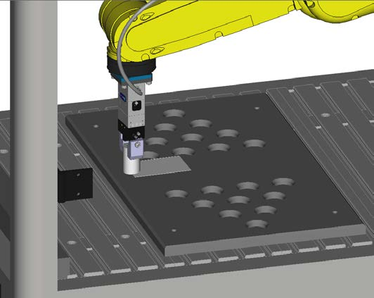

And RECORD this position as Y-Direction Point – see below:

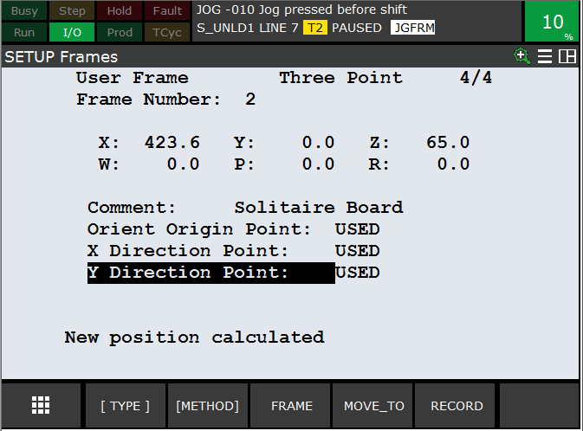

Note – Y-Direction Point defines the X-Y plane, so any position in the right plane will do.

This procedure will touch-up / re-teach the UFrame #2

21



**5**

**Robot Setup**

**5.1**

**UTOOL / TCP Setup**

Because of the simple shape and mounting of the Schunk gripper, a simple TCP with an offset of

115mm in Z is sufficient.

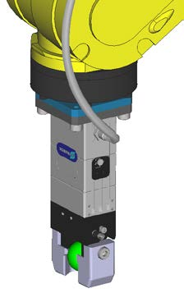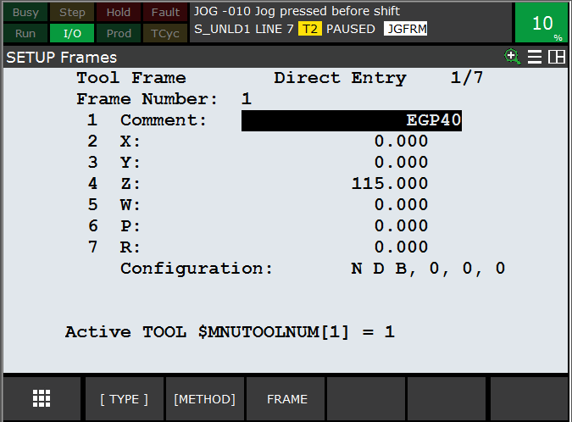

**5.2**

**Payload Setup**

The payload is quite low for this application – so only one payload of 0.5 kg has been set:

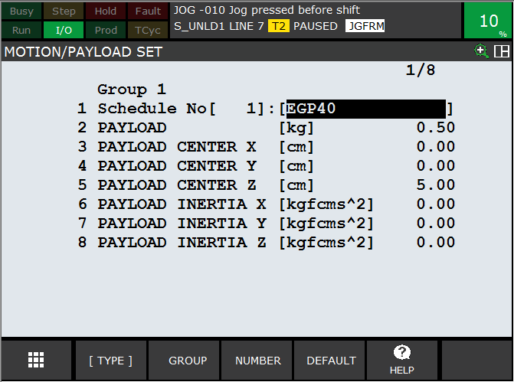

22



**5.3**

**DCS Setup**

DCS (Dual Check Safety) has been used to ensure that the robot cannot accidentally hit the walls of

the cell. This requires setting up a Tool Model and a Safe Zone.

**5.3.1**

**DCS Tool Model.**

A simple DCS model using one “Line_seg” type model has been used.

For more details please refer to DCS manuals.

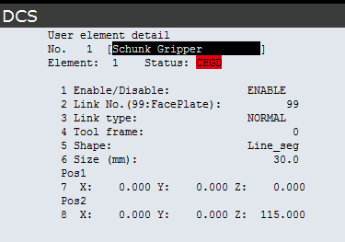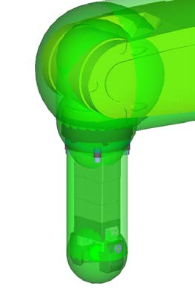

23



**5.3.2**

**DCS Safe Zone**

A simple DCS Cartesian Position Check Zone has been set up using a Diagonal line to define a

cuboid zone, running from a point on the “ top left “ of the cell to the “bottom right “ – see

screenshot below - where the inside of the cuboid is safe.

If the robot or the tool comes close to the edge of this zone, the robot will stop.

For more details please refer to DCS manuals.

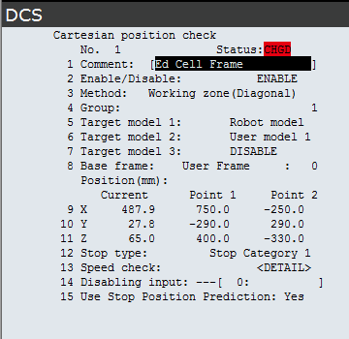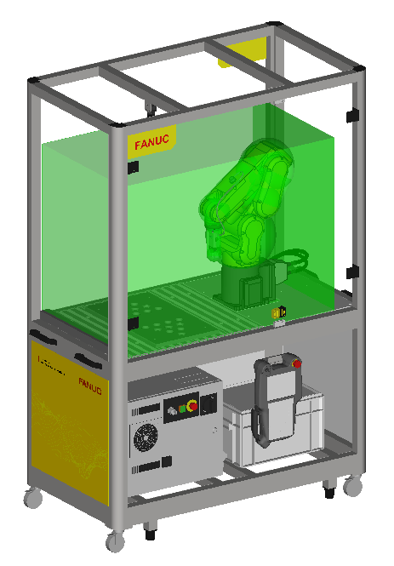

24



**5.4**

**I/O Setup**

Only 2 I/Os are used, for gripper Open / Close

These outputs are configured as Complementary, so when, for example RO[7] is set ON, RO[8] is

automatically forced to OFF and vice-versa.

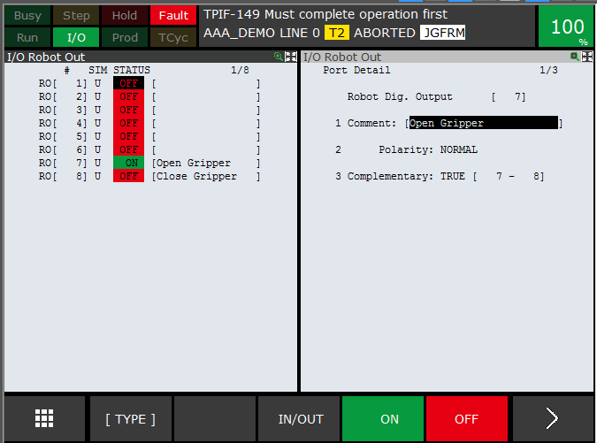

25



**5.5**

**Macro Setup**

One macro has been set up, to allow the user to easily toggle the gripper open / close using SHIFT

+ User Key 1 on the Teach Pendant:

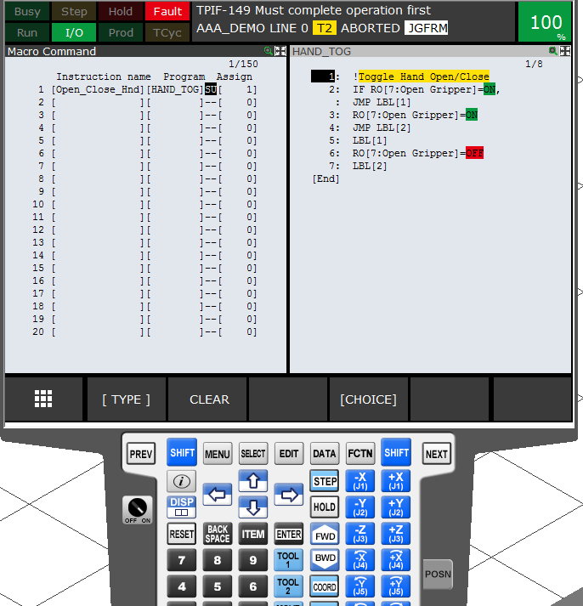

26



**5.6**

**TP Function Key Hint Screen**

To allow the user to easily remember the setting of the Function Key, a Hint Screen has been set

up using an HTML Page:

When the “Menu” key is pressed, the Shortcut key F2 “FKey” pops up:



Pressing F2 will display the FKey Hint

screen:

This screen shows the current

assignment of the function keys.

The text which is displayed is the text

stored in String Registers SR[21] –

SR[25]

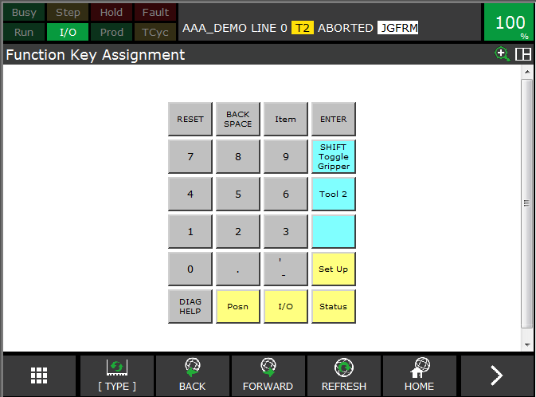

27



**5.7**

**Home / Reference Position**

One reference position has been set up, which is used for the HOME position check. Home position

is this:



And setup is this:

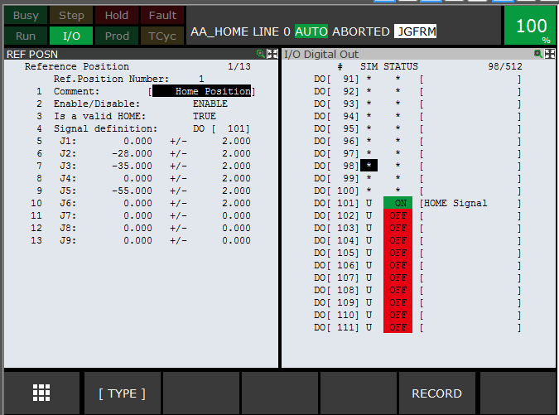

When the robot is in this position, the output DO [101] will be ON – and this can be checked by the

TP program AA_CHK

28



**5.8**

**Power Up Program**

To provide instructions to the user, a Power-Up program “PWR_UP.TP” has been assigned to both

Hot Start and Cold Start.

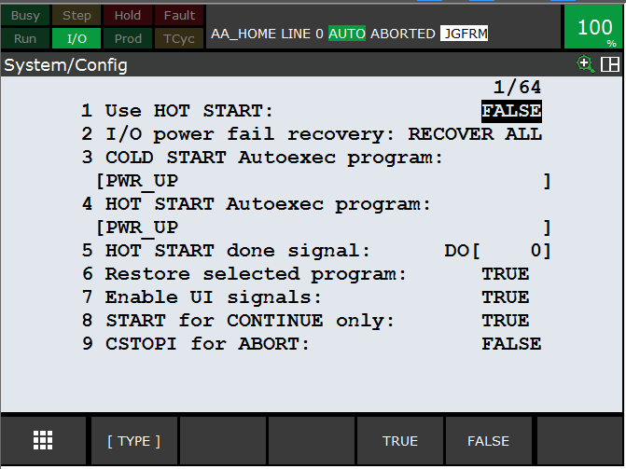

The program simply writes instructions to the Teach Pendant:



29



**6**

**RVision Setup ( Option )**

***i***

The Education Cell is available with and without integrated

RVision using KOWA video camera.

*i*

In either case, the

RVision Setup has not been done on the Education Cell controller. Please

*i*

contact your local FANUC representative to arrange training on

RVision

*i*

The following section is just to give a short overview of a sample

RVision setup, and is not intended

*i*

to take the place of a proper

RVision training.

*i*

**6.1**

**Camera Adjustment**

If this option has been ordered, the basic camera setup should already have been done by FANUC

Europe, so the camera should display an image something like this:

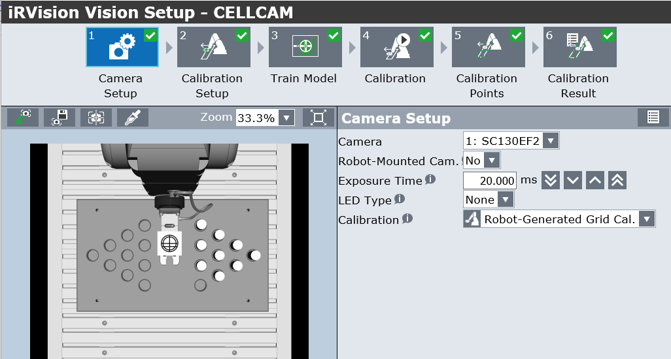

30



If the Camera View is not like this, then please adjust using the screws on the Camera Mounting

bracket:

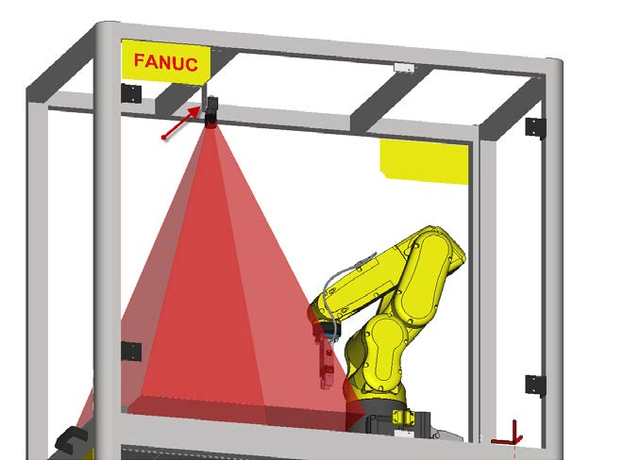

31



**6.2**

**Application Frame**

It is good practice to set up an Application Frame to use with

RVision, for example Uframe 9.

*i*

This can be done in the same way as for the UFrame 2 Setup

Orient Origin Point:

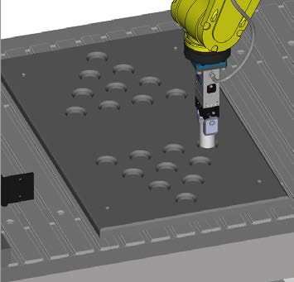

X-Direction Point:

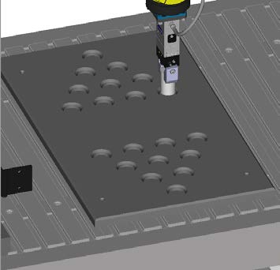

Y- Direction Point:

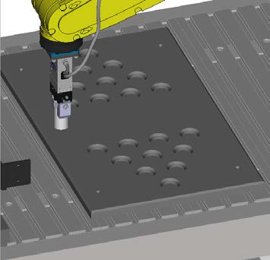

32



**6.3**

**Camera Calibration**

The

RVision Calibration Grids are not included in the Education Cell. Instead the “Robot Generated

*i*

Grid Calibration” Method can be used – please refer to the

RVision Operation Manual for details.

*i*

Basically a target should be temporarily attached to the Gripper as shown:

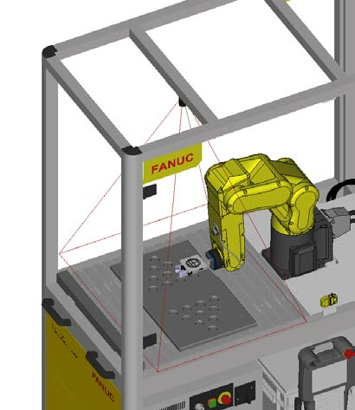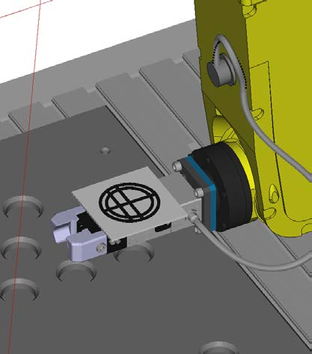

(The design of the target is explained in the

RVision manual – it should be approx. 50mm

*i*

diameter)

It will appear something like this in the camera field-of-view:

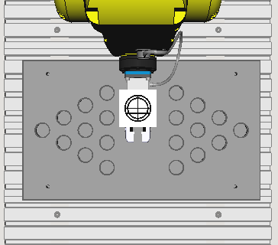

33



The Camera Calibration takes place in 2 steps:

First find the relationship of the target to the robot

•

Second move the target around the field of view to calibrate the camera

•

**Please note that it may be necessary to disable DCS while calibrating the camera field of view**

**since the robot moves the target right to the edges of the field of view, close to the side walls.**

All of this is done through the Teach Pendant using the

RVision Utilities Menu:

*i*

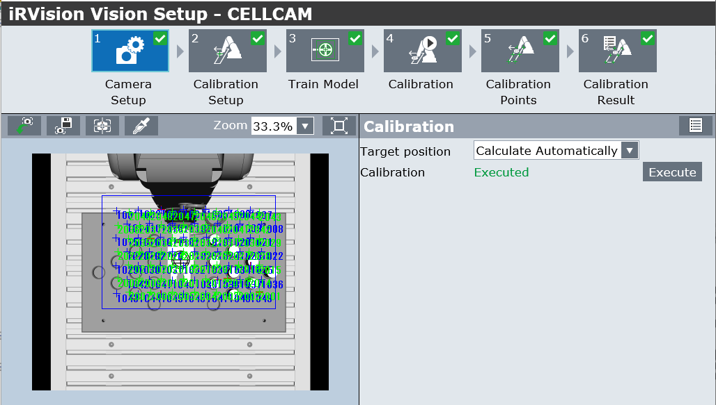

For details please refer to the

RVision Operation Manual. Note that for the Start Position, there

*i*

must be enough space between the robot wrist and the cell – approx. 70mm is good:

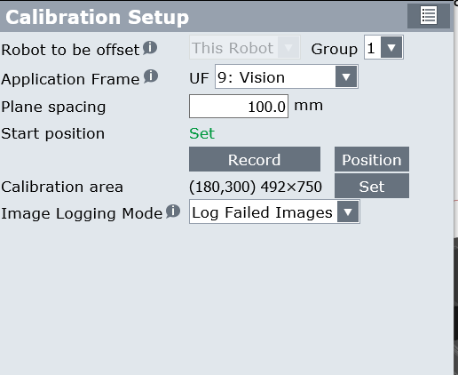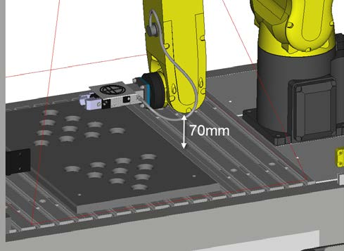

34



**6.4**

**Example**

**RVision Application**

***i***

A simple application could be to load the parts from the centre of the board into the starting

position for the Solitaire program

So the parts start like this,

And end like this,

randomly placed in the centre of the board

in the start position for ‘Solitaire’

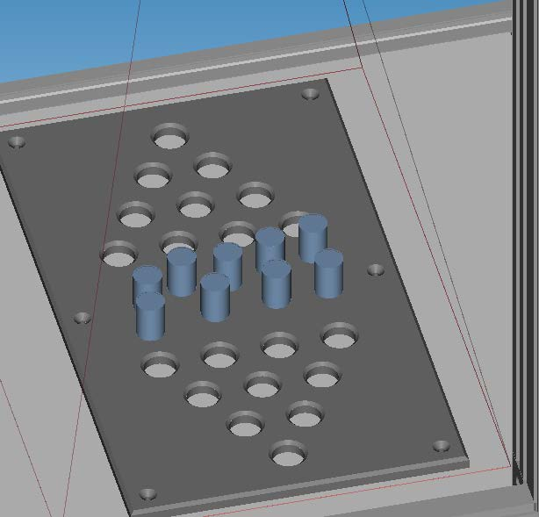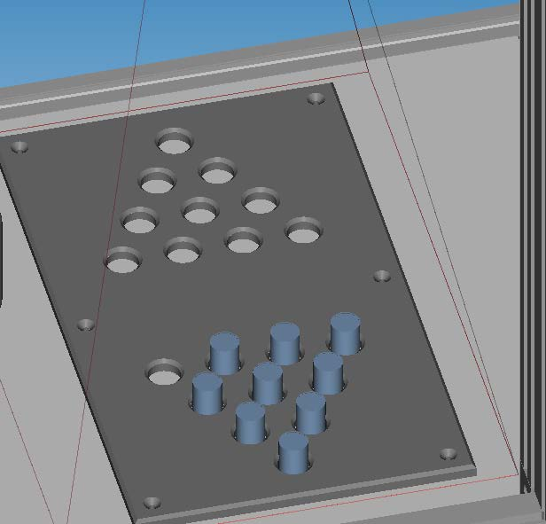

Using FANUC

RVision this is quite straightforward to do:

*i*

Calibrate the Camera (as shown previously)

•

Teach a reference pick-up position for one of the parts

•

Teach

RVision to recognise and locate one of the parts.

•

*i*

Create a TP program to use the

RVision information to pick the part and then place into

•

*i*

the board.

(This was suggestion but has been now added to the demo cell as shipped by FANUC – see

section 1.3)

35



**6.5**

**RVision Tips**

***i***

FEC set this application up using the Vision Process below:

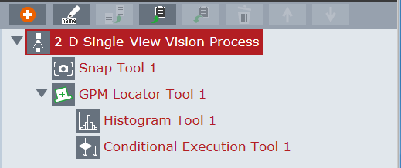

A simple GPM locator tool to find the cylindrical part

•

The GPM Locator has a search window to restrict the vision to the centre of the board to

•

avoid finding the ‘holes’ instead of the parts:

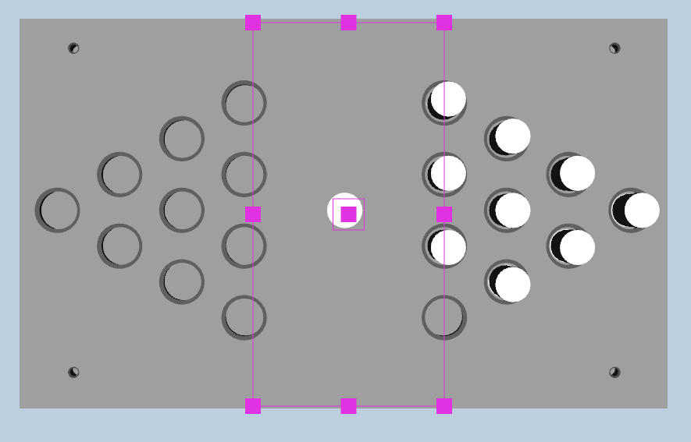

36



Then the Histogram Tool and the Conditional Execution Tool are used to make sure that

•

there is enough free space around the part to allow it to be picked up.

So all of these parts can be picked:

But the two central parts here cannot be

picked because they are too close together.

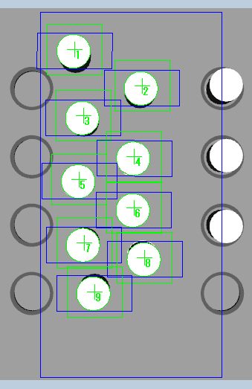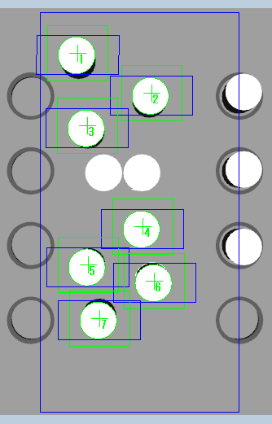

37



**6.6**

**TP Program**

Write a simple TP program to Pick and Place the parts:

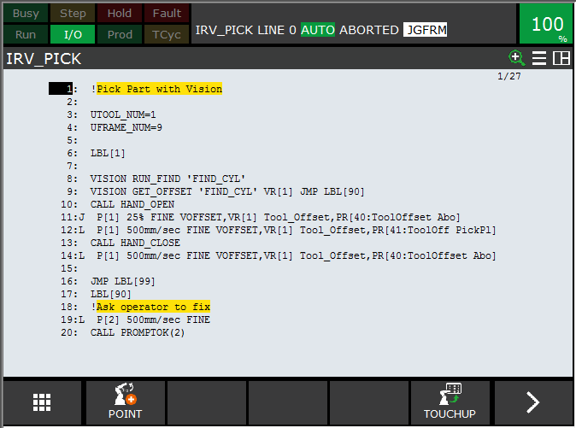

It is advisable also to add in some simple error handling to check that the Vision is working OK.

This can be done using the Menu Utility as described in section 7

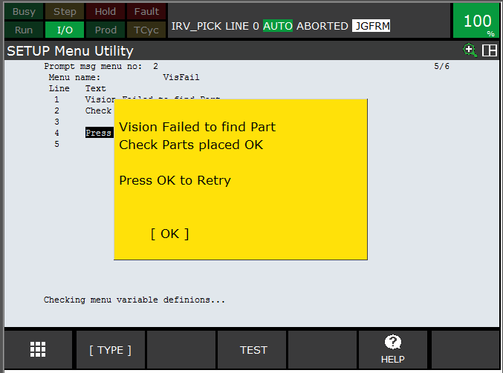

For more details please refer to the

RVision Operation Manual or arrange training with your local

*i*

FANUC Europe representative.

38



**7**

**IoT / Industrie 4.0 / PC Connection**

The FANUC Europe Education Cell is delivered ready for connection to a PC or to a Network via

Ethernet to allow full connectivity ( For full details please refer to the FANUC Ethernet Function

OPERATOR'S MANUAL B-82974EN/04).

**7.1**

**Physical Ethernet connection**

The maximum distance between controller and Hub or PC is

100m.

The Ethernet cable should be fastened by a cable clamp as

shown below to prevent tension being applied to the RJ-45

connector.

This clamp also grounds the cable shield.

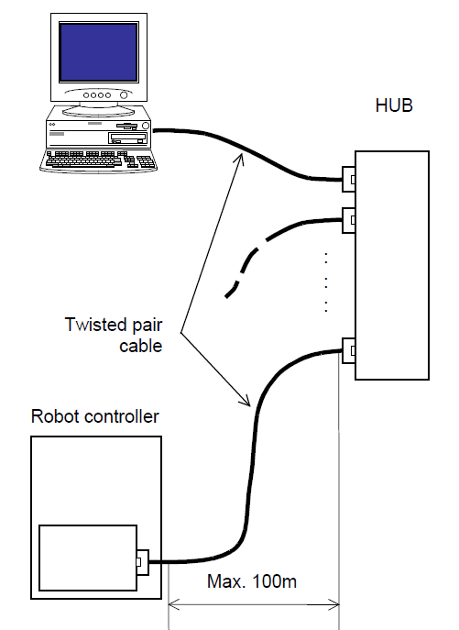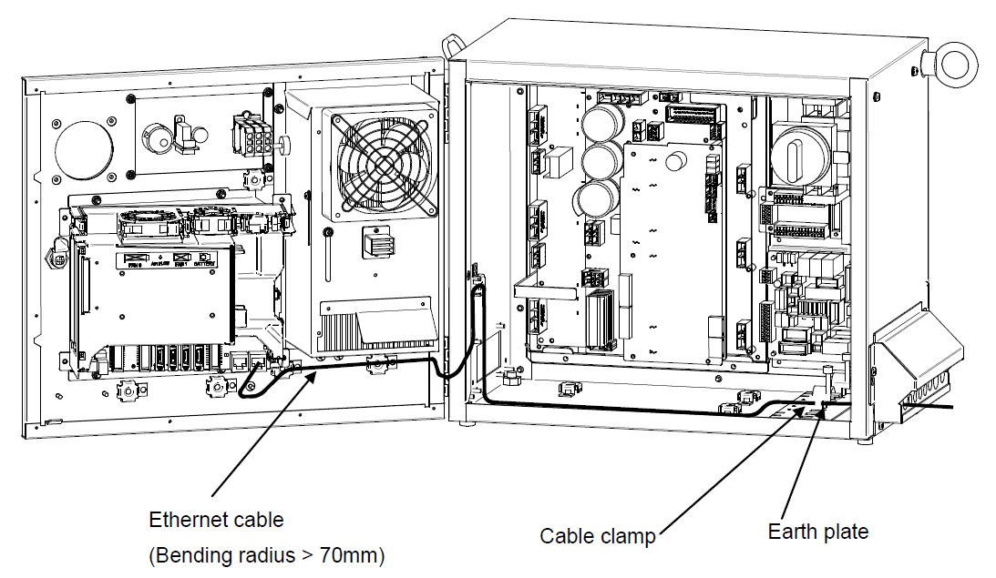

39



**7.2**

**Robot Software Setup**

To set up the Ethernet communication between PC and robot, select:

MENU>SETUP>Host Comm> TCP/IP > DETAIL:

Please set a suitable IP Address and Subnet Mask

Other settings may be required depending on your

specific network connections.

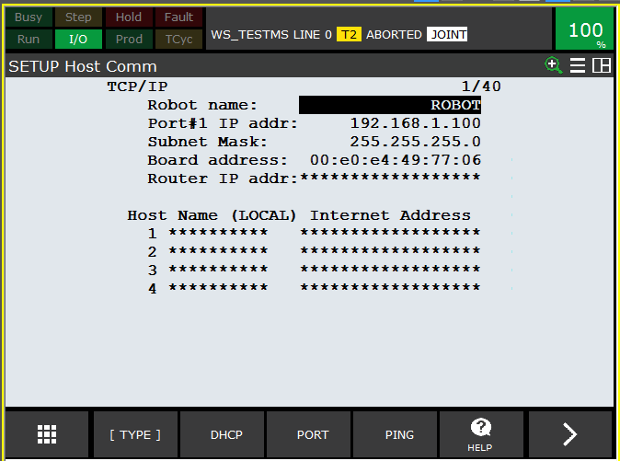

To allow full access from remote device, select: MENU>SETUP>Host Comm> TCP/IP > DETAIL:

Please ensure that these resources are set to ‘U’

– Unlocked – to allow access.

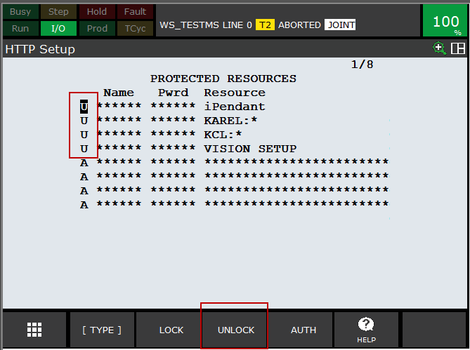

( If you do not do this then you may see a message

such as the one shown here )

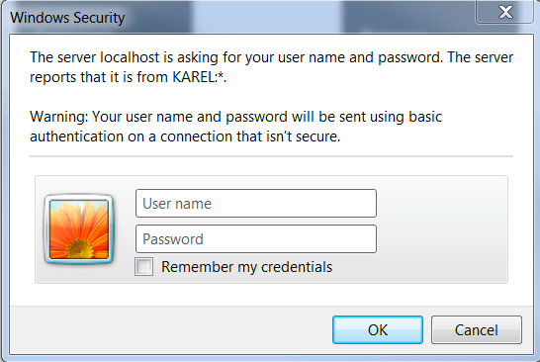

40



**7.3**

**PC Setup**

There are different ways to set up the PC to communicate to the robot, depending on whether the

PC will be permanently or temporarily connected. In either case the IP Address and Subnet mask

must be suitably set:

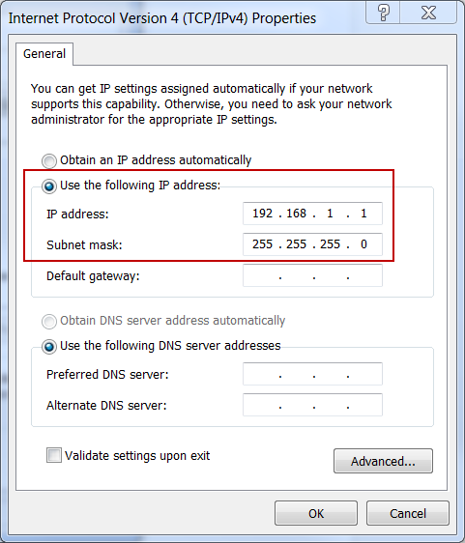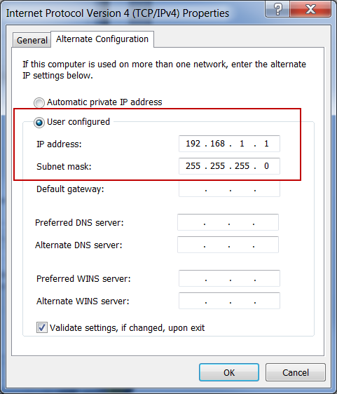

41



**7.4**

**Robot Homepage**

Once the setup has been done, the Robot Homepage can be accessed from the PC by typing in the

Robot IP address:

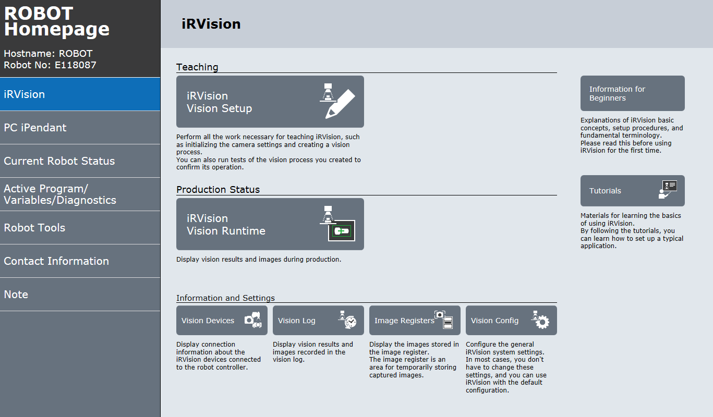

From this Homepage, sub-pages can be accessed giving access to the internal robot controller

data:

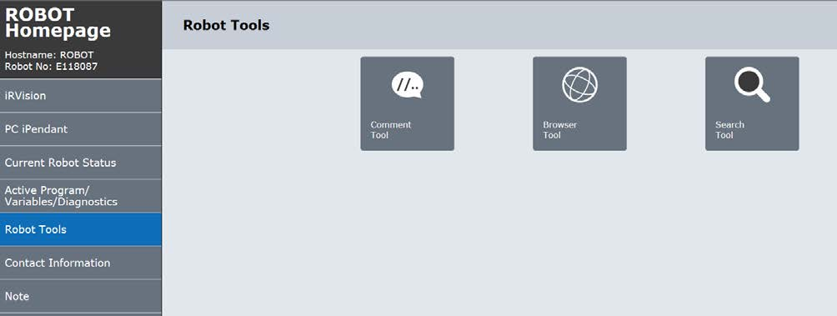

42



For instance the Comment Tool which allows quick access to comments and data – the example

below shows Numeric Registers:

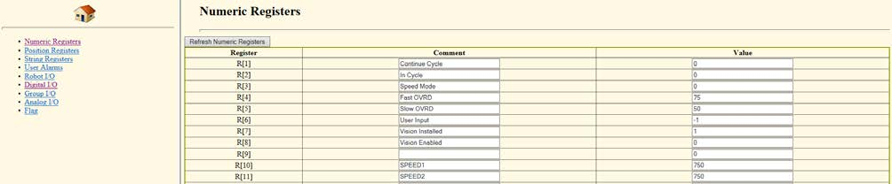

Or the user can access the TP programs in the controller:

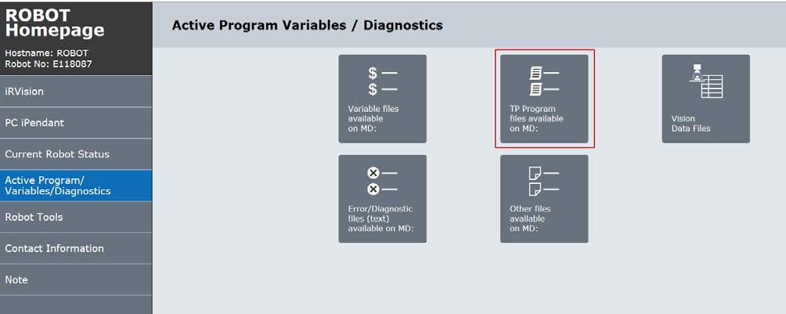

Select a program:

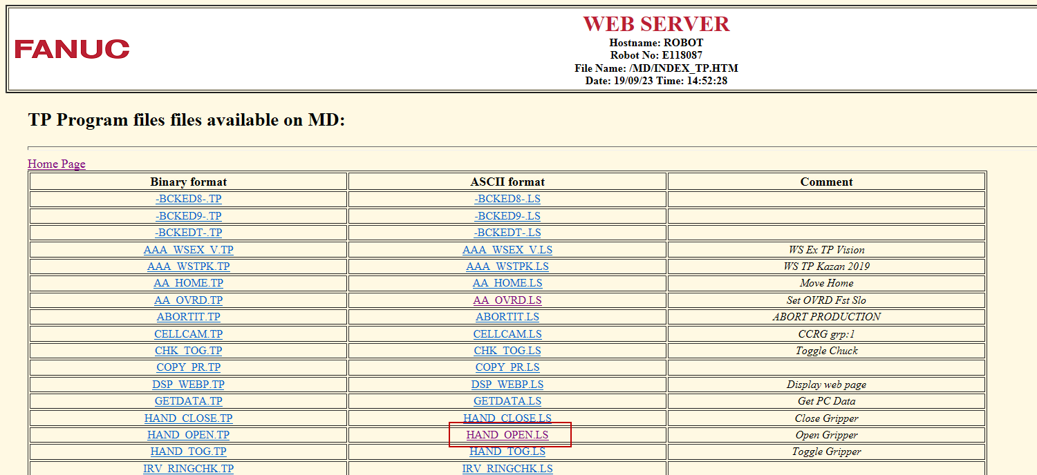

43



And see the program contents:

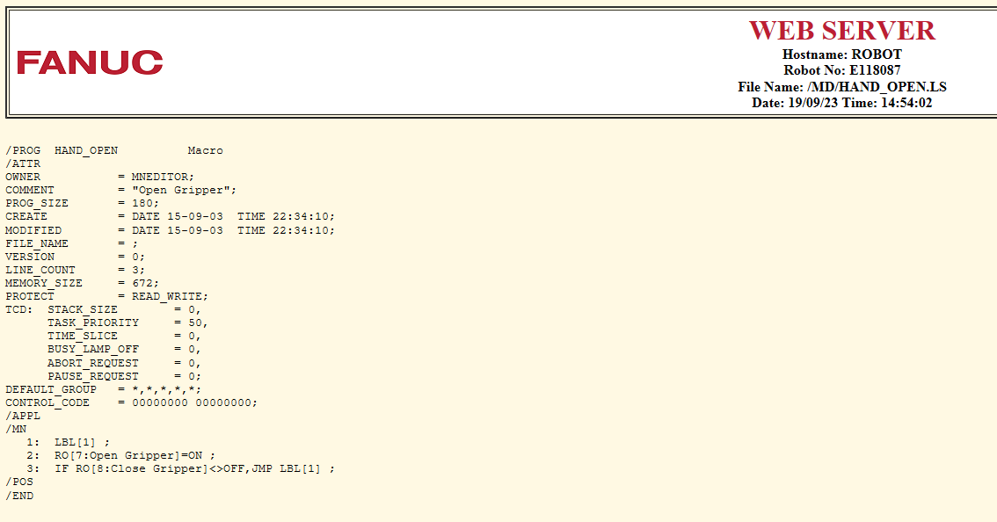

**7.5**

**File Transfer**

After the connection between PC and Robot has been established, files can be transferred between

them.

See example below – copy and paste of program ‘aaa_test.tp’ using simple

‘ftp://[robot_ip_address] – other software such as Filezilla can also be used.

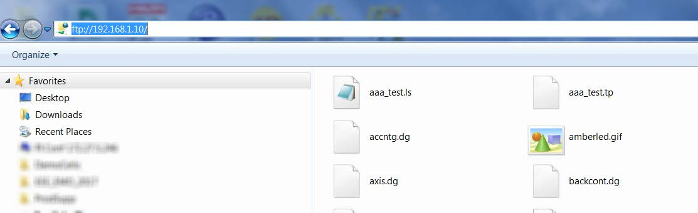

44



**7.6**

**Roboguide Simulator / File Transfer**

File transfer can also be set up to work between Roboguide and the real robot:

First select Tools > Simulator:

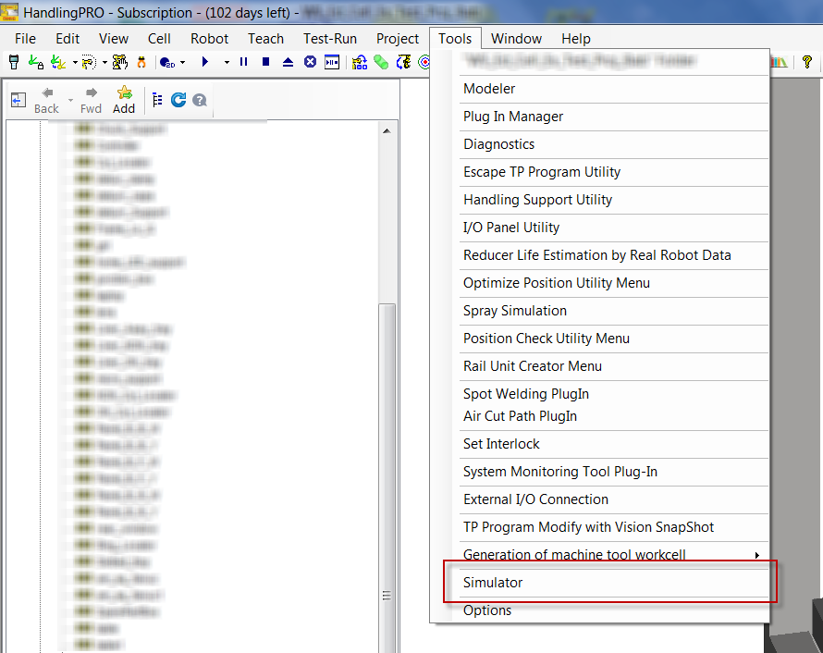

45



Then set up the Simulator to communicate with the real robot connected via Ethernet:

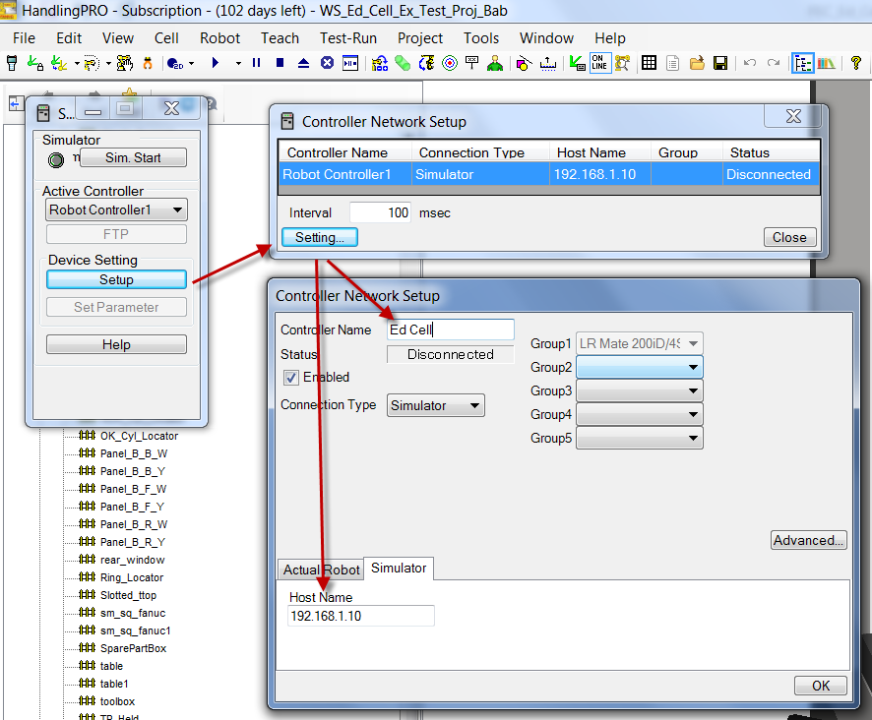

Once setup has been done, the Simulator function can be started and FTP selected:

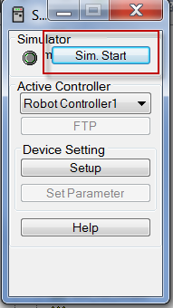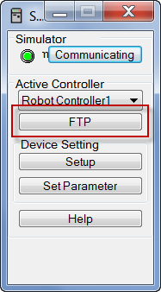

46



**Now files can easily be transferred between Roboguide and real robot:**

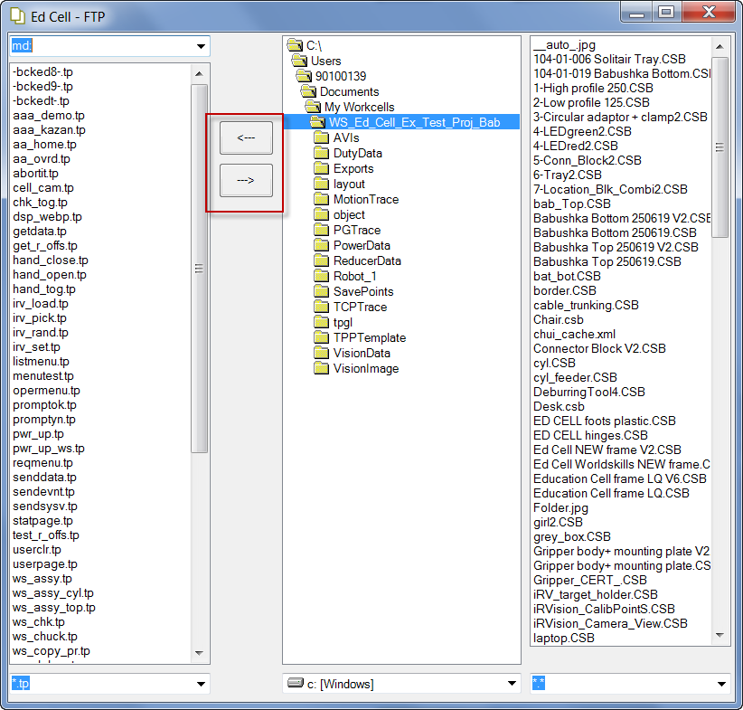

Please note that this is not the only function of the Simulator function.

For example - when the Simulator is active, the robot in the Roboguide workcell will mimic the

movement of the real robot. For more details please refer to the Roboguide help files.

47



**8**

**List of Registers**

**8.1**

**Numeric registers**

Registers are used to store settings to control the cell operation, and used by the program internally.

**Register**

**Comment**

**Description**

**Default value**

1

Continue Cycle

This register is set to 1 at start of

1 to loop

“AAA_DEMO”. If value is 1 then the

0 to end

program will loop continuously.

If value is 0, program will stop at end of

next full cycle.

Value can be set manually or by the

Menu screen described in earlier

section.

2

In Cycle

This register is set to 1 at start of

1 when in cycle

“AAA_DEMO”, and is set to 0 at end of

0 at end of cycle

program

3

Speed Mode

This register is set via the Menu screen

1 is fast mode,

described earlier.

anything else

slow.

4

Fast OVRD

This is value that will be used for

75%

Override in Fast Mode

5

Slow OVRD

This is value that will be used for

50%

Override in Slow Mode

6

User Input

Used by the Menu Utility to return the

1

User’s Choice of actions

7

Vision Installed

This should be set during software

1 is installed,

installation / setup.

anything else not

installed

8

Vision Enabled

This is set by the Operation Menu to

1 is enabled,

enable / disable Vision L/UL. Both R[7]

anything else not

and R[8] must be 1 for the vision section

enabled

of the example program to run

750mm/sec

These are speeds and acceleration

SPEED1

10

750mm/sec

used for moves. They are set low to

SPEED2

11

75%

avoid frame shaking when on wheels.

ACC

12

(If frame is fixed more securely, speed

and acceleration could be increased)

48



**Register**

**Comment**

**Description**

**Default value**

n/a

13

CURR PIN

This value is used internally by the

program to keep track of the part

number

16

IRV COUNT

Used to load 9 parts with Vision

n/a

n/a

These values are used internally by the

ID_PICK_CYLINDER

100

program to control the sequence of

ID_PLACE_HOLE

101

moves

ID_REMOVE_CYLIND

102

ID_EMPTY_PLATE

103

105

Tmp_cyl_reg

This value is used internally by the

n/a

program to set the status registers

below

1 = occupied

These registers are used to store the

A1 in

111

0 = unoccupied

status of the parts and holes.

to

to

The values in these registers are linked

-D4 in

130

to the Menu Displays using the

Pendant

*i*

Controls – see later section

49



**8.2**

**Position Registers**

Position Registers are used to store positions

**Comment**

**Description**

**Position**

**Register**

Locations of the holes in the tray.

A1

11

Note that these are calculated values, not taught values.

to

to

-D4

30

PR[11] was taught, then the other PR[]s were calculated

relative to it.

31

Mid 1

‘Random’ positions in middle of board – not in holes – robot

to

to

will find actual position using

RVision

*i*

39

Mid 9

40

ToolOff

These are Tool Offsets, used to create the motion above / to the

41

ToolOff1

pick and place locations.

The Registers can be displayed using the ‘Data’ button on the Teach Pendant:

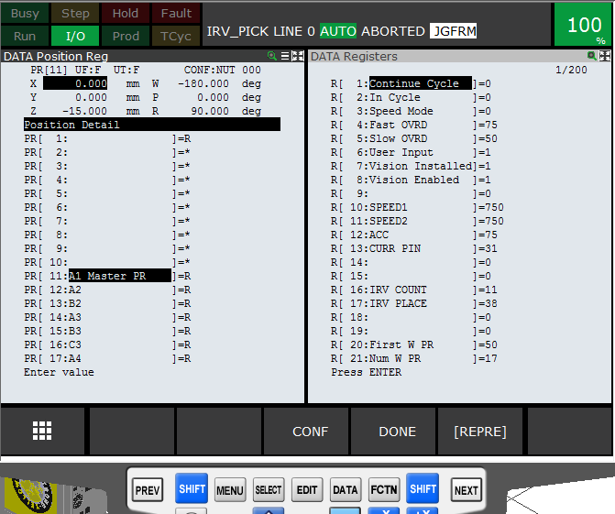

50



**9**

**Program Details**

**9.1**

**List of programs**

The following programs are installed in the Education Cell:

**Program**

**Comment**

**Description**

AAA_DEMO

Example program

This is Main Example program – it must be

selected before pressing ‘Cycle Start’

AA_CHK

Check Start OK

Program to check robot at home and parts in

correct position.

Uses Menu Utility to display choices and

confirmation to user – see later section for details.

Also uses .STM file to display graphic of correct

part position – see later section for details.

AA_HOME

Move Home

This program moves the robot to the home

position. Note that it uses Joint definition position –

so independent of any UFrame or UTool settings

AA-OVRD

Set OVRD Fst Slo

Set override to value specified in R[4], R[5]

depending on value of mode R[3]

ABORTIT

ABORT PRODUCTION

Predefined system program – not used by this

application

DSP_WEBP

Display Web Page

Macro installed by the ‘Menu Utility’ Option.

This macro is used to display the Menu Screens.

GETDATA

Get PC Data

Predefined system program – not used by this

application

HAND_CLOSE

Close Gripper

Program to Close Schunk Gripper ( Note 1)

HAND_OPEN

Open Gripper

Program to Open Schunk Gripper ( Note 1)

HAND_TOG

Toggle Gripper

Program to toggle gripper between Open and

Close.

This program is linked to the User Key 1 on the

Teach Pendant – see details in later section

IRV_LOAD

Get Parts Vision

Pick parts from centre of board using vision and

place in left hand side of board

IRV_PICK

Get 1 Part

Pick 1 part from centre of board using vision and

place in left hand side of board – called from

IRV_LOAD

51



**Program**

**Comment**

**Description**

IRV_RAND

Put Parts Vision

Pick parts from Right hand side of board and place

in semi-random positions on middle of board for

robot to find using

RVision

*i*

IRV_SET

IRV Setup Posn

Program containing suitable start position for

RVision Camera Calibration

*i*

LISTMENU

LIST MENU MACRO

Macro installed by the ‘Menu Utility’ Option.

This macro is used to display 3 choices to the user

when the robot is not at HOME

OPERMENU

Entry Menu Macro

Macro installed by the ‘Menu Utility’ Option.

This macro is not used in this application

PROMPTOK

Prompt Box OK

Macro installed by the ‘Menu Utility’ Option.

This macro is not used in this application

PROMPTYN

Prompt Box Y N

Macro installed by the ‘Menu Utility’ Option.

This macro is used to confirm the choice by the

user when the robot is not at HOME

REQMENU

Request PC Menu

Predefined system programs – not used by this

SENDDATA

Send PC Data

application

SENDEVNT

Send PC Event

SENDSYSV

Send PC Sysvar

STATPAGE

StatusMenu Macro

S_SET1_PR

Solit Setup 1PR

Set coordinates of one Position Register for one

hole

S_SETUP_PRS

Solit Setup PRs

Set coordinates of all Position Register for all holes

S_SOLIT_RESET

Reset Status Rs

Reset registers showing part status to start

conditions

S_UNLD1

Solit Unload 1

Make one move, jumping over a piece and then

moving the jumped-over piece to the other half of

the board.

S_UNLDALL_L

Solit Unl All L

Sequence for the left side of the board, moving

pieces to the right side

S_UNLDALL_R

Solit Unl All R

Sequence for the right side of the board, moving

pieces to the right side

S_UNLDLST

Solit Unld Last

Make one move – for first or last pieces

USERCLEAR

Clear User Page

Macros installed by the ‘Menu Utility’ Option.

USERPAGE

Show User Page

These macros are not used in this application

ZERO

Move to Zero

Move all axes to zero

52



**Note 1)** In order for the Roboguide Simulation to work correctly picking and placing the virtual parts,

the HAND_CLOSE and HAND_OPEN .TP programs must be replaced with Simulation programs.

Please refer to actual Roboguide cell for details

53



**9.2**

**Sample Program Listings**

This is listing of main program “AAA_DEMO”:

/PROG AAA_DEMO

1: !FANUC EUROPE EDUCATION CELL ; << Remark

2: !Example Solitaire Program ; << Remark

3: !with optional vision ;

4: CALL AA_CHK ; << Call program to check Start OK

5: R[1:Continue Cycle]=1 ; << Set Register to run continuously

6: R[2:In Cycle]=1 ; << Set Register to show status

7: CALL AA_OVRD ; << Call program to set Override %

8: CALL HAND_OPEN ; << Make sure gripper is open

9: LBL[1] ; << Label to loop up to if needed

10: CALL S_SOLIT_RESET ; << Reset status registers

11: CALL S_UNLDALL_L ; << Sequence to move pieces from Left to Right side of board

12: WAIT 2.00(sec) ; << Short delay

13: IF R[7:Vision Installed]<>1,JMP LBL[2] ; << Check if use Vision or not

14: IF R[8:Vision Enabled]<>1,JMP LBL[2] ; << Check if use Vision or not

15: CALL IRV_RAND ; << Move parts from Right of board to Middle

16: WAIT 2.00(sec) ; << Short delay

17: CALL IRV_LOAD ; << Pick parts from Middle of board using Vision and put in Left Side

18: WAIT 2.00(sec) ; << Short delay

19: JMP LBL[3] ; << Jump over next section

20: LBL[2] ; << Label for Jump

21: CALL S_UNLDALL_R ; << Sequence to move pieces from Right to Left side of board

22: LBL[3] ; << Label for Jump

23: WAIT 2.00(sec) ; << Short delay

24: IF R[1:Continue Cycle]=1,JMP LBL[1] ; << Repeat if register 1 is equal to 1

25: R[2:In Cycle]=0 ; << Set register to show status at end of program

/POS

/END /END

54



This is listing of program “AA_CHK”:

/PROG AA_CHK

1: !Check Start Conditions OK ;

<< Remark

2: ;

3: !Check at HOME ;

<< Remark

4: IF DO[101:HOME Signal]=ON,JMP LBL[10] ; << Check HOME signal – see later section for detail

5: LBL[1] ;

6: R[6:User Input]=0 ;

7: CALL LISTMENU(2,6) ;

<< Call Menu Utility to display User Menu 2, result in R[6]

8: SELECT R[6:User Input]=1,JMP LBL[3] ;

9: =2,JMP LBL[5] ;

10: ELSE,JMP LBL[2] ;

11: LBL[2] ;

12: ABORT ;

13: JMP LBL[10] ;

14: LBL[3] ;

15: CALL AA_HOME ;

16: JMP LBL[10] ;

17: LBL[5] ;

18: R[6:User Input]=0 ;

19: CALL PROMPTYN(2,6) ;

<< Call Menu Utility to display Prompt Box 2, result in R[6]

20: IF R[6:User Input]=1,JMP LBL[10] ;

21: JMP LBL[1] ;

22: LBL[10] ;

23: ;

24: !Check parts OK ;

25: CALL S_SOLIT_RESET ;

26: R[6:User Input]=0 ;

27: !Display Check Page ;

28: CALL DSP_WEBP(3) ;

<< Call Menu Utility to display User Status / Confirmation Menu

29: WAIT R[6:User Input]<>0 ;

30: IF R[6:User Input]=1,JMP LBL[20] ;

31: ABORT ;

32: LBL[20] ;

33: !Display Run Page ;

34: CALL DSP_WEBP(4) ; << Call Menu Utility to display User Status / Operation Menu

/END

55



**10**

**User Interface Setup**

**10.1**

**Menu Utility Setup**

The User Menu and Prompt at the start of the AA_CHK program have been set up using the Menu

Utility. See below for screenshots.

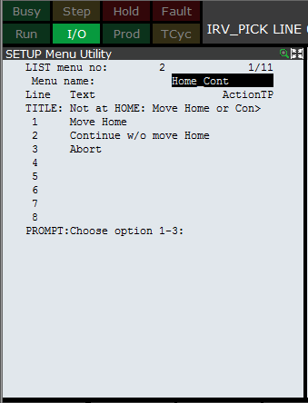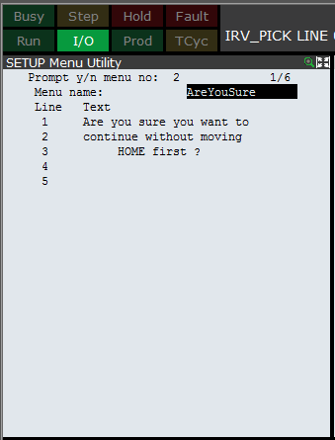

Once these menus have been set up, they can be called using the predefined macros “LISTMENU”

and “PROMPTYN”

56



**10.2**

**HTML Screens**

The Status / Menu Screens were created using MS Sharepoint Designer 2007:

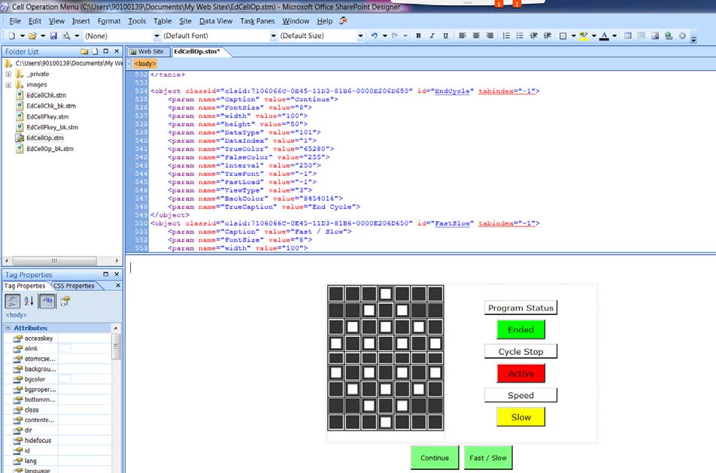

Then the files were loaded into the controller and added to the browser favourites menu:

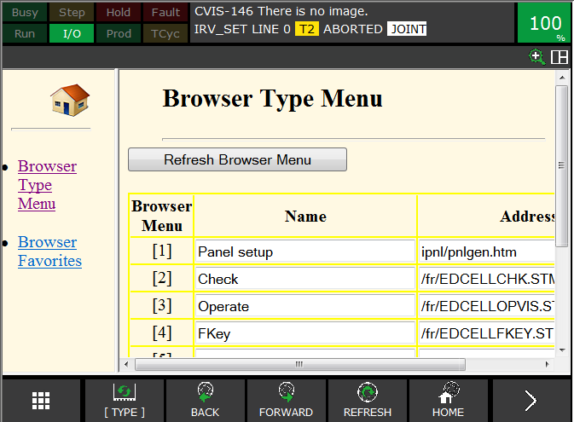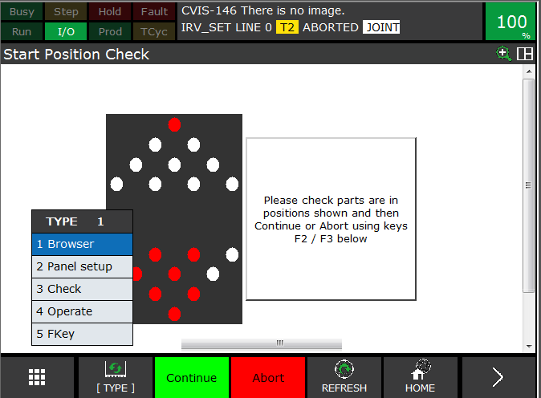

program, which is included in

So that they can be displayed manually or using the

CALL DSP_WEBP(3)

the Menu Utility

57



**10.3**

**HTML Listing Extract**

This is extract of listing for “EdCellOp.stm”

<head>

Title of the Page

<meta http-equiv="Content-Language" content="en-gb">

<meta http-equiv="Content-Type" content="text/html; charset=utf-8">

<title>Education Cell Menu</title>

<style type="text/css">

.style1 {

border-color: #FFFFFF;

border-width: 0;

background-color: #333333;

}

.style2 {

text-align: center;

}

</style>

</head>

<body>

<div class="style2">

<table style="width: 41%"> Table with two columns, left column for board layout, right column for

status boxes

<tr>

<td style="width: 235px">

<table style="width: 140px; height: 180px; float: right;" class="style1">

<tr>

Table with 7 columns and 9 rows to show board positions

<td></td>

<td></td>

<td></td>

58



<td style="width: 30px">

Definition of one board position

<object

classid="clsid:71060668-0E45-11D3-81B6-0000E206D650"

id="Sol1"

style="width: 20px; height: 20px">

<param name="Caption" value="">

<param name="FontSize" value="14">

<param name="width" value="20">

<param name="height" value="20">

<param name="DataType" value="101"> State linked to Register

<param name="DataIndex" value="121"> Register number 121

<param name="TrueColor" value="255"> True Colour = Red

<param name="FalseColor" value="16777215"> False colour = Light grey

<param name="Interval" value="250">

<param name="TrueFont" value="-1">

<param name="FastLoad" value="-1">

<param name="Border" value="1">

<param name="ViewType" value="1">

</object>

</td>

<td></td>

<td></td>

<td style="width: 49px"></td>

</tr>

Repeat for all other board positions up to 20

</table>

Set up objects in right column

</td> Add label

<td class="style2">

<object classid="clsid:7106065C-0E45-11D3-81B6-0000E206D650" id="FRIPLabel1"

style="height: 30px; width: 150px">

<div class="style2">

<param name="Caption" value="Program Status">

59



<param name="FontSize" value="10">

<param name="width" value="150">

<param name="height" value="30">

<param name="DataType" value="100">

<param name="DataIndex" value="">

<param name="Interval" value="250">

<param name="TrueFont" value="-1">

<param name="FastLoad" value="-1">

</div>

</object>

<br>

Add Lamp Object to show status of program

<object

classid="clsid:71060668-0E45-11D3-81B6-0000E206D650"

id="FRIPToggleLamp4" style="height: 40px">

<div class="style2">

<param name="Caption" value="Ended"> Set text for False

<param name="FontSize" value="10">

<param name="width" value="100">

<param name="height" value="40">

<param name="DataType" value="101"> Link to Register

<param name="DataIndex" value="2"> Register 2

<param name="TrueColor" value="255">

<param name="FalseColor" value="65280">

<param name="Interval" value="250">

<param name="TrueFont" value="-1">

<param name="FastLoad" value="-1">

<param name="TrueCaption" value="In Cycle"> Set Text for True

</div>

</object>

<br>

Repeat for other lamps

</table>

60



Add TP Key labels / functions objects

<object classid="clsid:7106066C-0E45-11D3-81B6-0000E206D650" id="EndCycle" tabindex="-1">

<param name="Caption" value="Continue">

<param name="FontSize" value="8">

<param name="width" value="100">

<param name="height" value="50">

<param name="DataType" value="101"> Sets Register

<param name="DataIndex" value="1"> Register 1

<param name="TrueColor" value="65280">

<param name="FalseColor" value="255">

<param name="Interval" value="250">

<param name="TrueFont" value="-1">

<param name="FastLoad" value="-1">

<param name="ViewType" value="3">

<param name="BackColor" value="8454016">

<param name="TrueCaption" value="End Cycle">

</object>

Repeat for other Key

</p>

<p>&nbsp;</p>

</div>

</body>

</html>

61



**11**

**Electrical Drawings**

**11.1**

**Power and Fence**

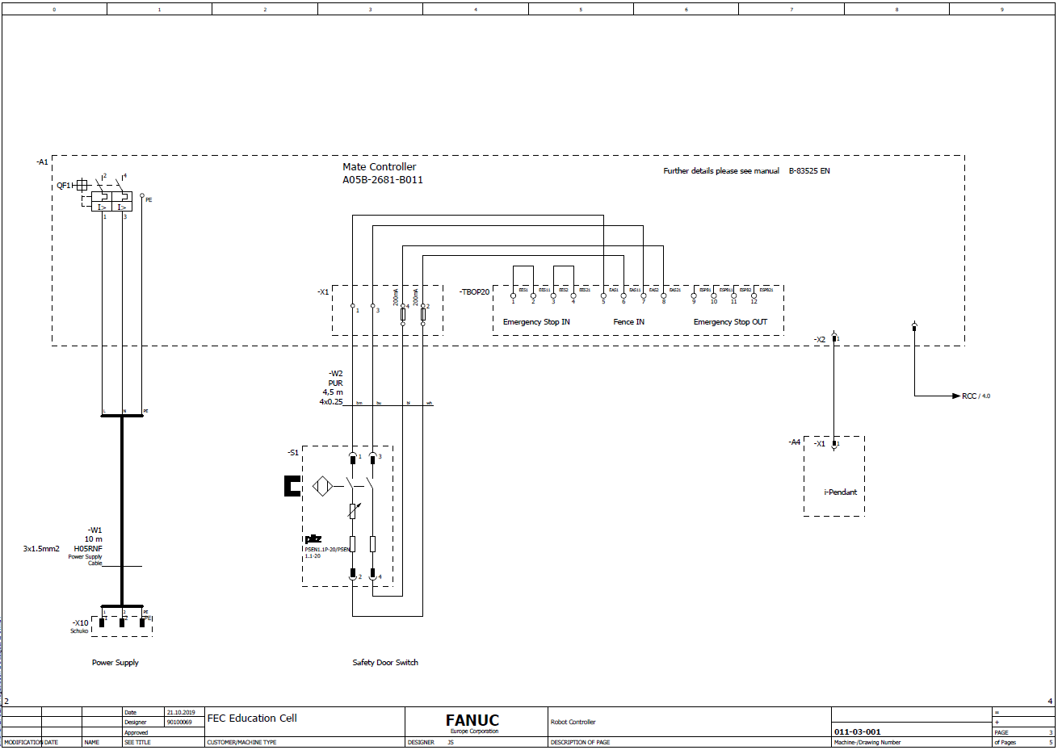

62



**11.2**

**Gripper**

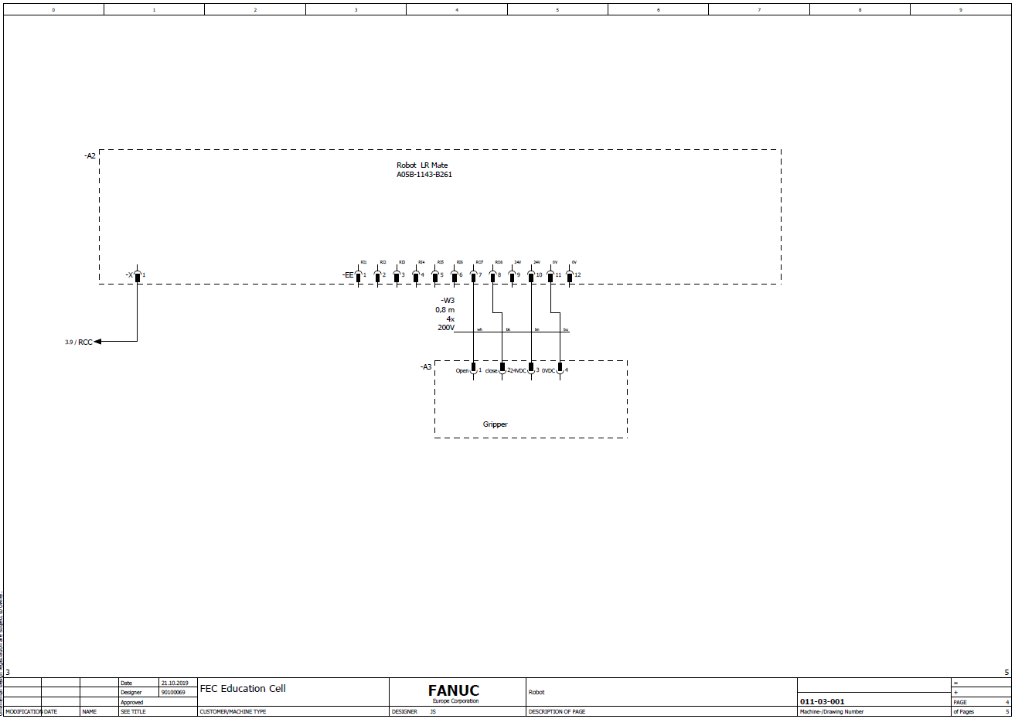

63



**12**

**Bill of Materials**

**Education Cell BOM (with**

**Item**

**Description**

**Vision)**

**Comments**

1

Robot, incl. Controller,

ER4IA-30P-M-ER1/0 ( ER-4iA)

New ER-4iA Robot for Education

Cables, TP etc

Market

2

iRVision option - Camera

A05B-1426-K001

KOWA Camera

Camera Cable

A05B-2680-J340

Lens

LX-1-RO-VI-16-0-0008

3

Frame, incl brackets, Parts

LX-1-RO-ZZ-17-0-0002 ( Silver)

Also includes 'Solitaire' board &

box etc

LX-1-RO-ZZ-17-0-0003 ( Black)

parts, and transport pallet

4

Schunk Gripper - EGP40

LX-P-RO-TS-15-0-0001

5

Gripper Fingers

LX-1-RO-TS-30-1-0001 ( x 2 )

6

Gripper Mounting Plates

LX-0-RO-ZZ-09-10021 +

LX-0-RO-ZZ-09-10022

7

EE Gripper Connection

Cable

LX660-4060-T901/L800R0

8

PILZ safety switch

LX-1-RO-ZZ-34-0-0001

PILZ PSEN1.1p-20

Cables & fuses safety switch

9

connection kit

LX-1-RO-ZZ-34-0-0004

10

Power Cable

LX-0-RO-ZZ-08-1-0007

Includes moulded on 220-240V

Power Plug

64



**13**

**Technical & Transport Data**

**Technical data:**

Power rating

230V 16A single phase

Power consumption

1 KW/h

Connection

Schuko plug (German style)

Air supply

None

Air consumption

None

Installation size

Base 1,3 x 0,7 m Height 1,8m

Weight

170kg

65



**Transport data**

Size

Base 1,3 x 0,7 m Height 1,8m

Weight

170kg

Packing

Bubble foil

Handling

Delivered on Pallet – When removed from pallet on wheels

**14**

**Version**

**Document title:**

Educational Package

Technical Documentation: ER-4iA Robot with R-30iB Mate Plus Controller

V5.1

Conversion from R-30iB Plus LR-Mate 200iD Sliding door type frame to R-30iB Plus

ER-4iA with Hinged door type frame. New HMI screens.

V5.2

IoT / Ind 4.0 Section added. Safety Section incl. DCS password advice added.

V5.3

Small changes to iRVision for s/w version 9.3

Version: V5.3 18-12-2019

N. Ramsden

66